UNIVERSITY INSTITUTE OF COMPUTING

PROJECT REPORT
ON
Student Performance Analysis

Program Name: BSC-CS
Data Interpretation
23SCP-354

SUBMITTED BY:

Name: Kanika UID: 23BSC10060
Branch: BSC-CS Section/ Group: 23BSC-1A
Semester: 6th D.O. Submission: 8-4-2026

SUBMITTED TO:

Name: Simranjeet Singh

Desigination: Assistant Professor
Sign: ____________________
\

BONAFIDE CERTIFICATE

Certified that this project report “Student Performance Analysis” is the Bonafide work of ”Kanika” under UID “23BSC10060” who carried out the project work under my supervision.

………………………………………
SIGNATURE
UIC DEPARTMENT
ASSISTANT PROFESSOR
Er. Simranjeet Singh

Student Performance Analysis
_________________________________________________________________________________________________
- Aim: -The primary aim of this project is to analyze and visualize student academic performance using Microsoft Excel. The project focuses on transforming raw student data into meaningful insights through the use of formulas, pivot tables, and interactive dashboards. It helps in identifying performance trends, weak areas, and overall student progress to support better academic decision-making.

- Performing Task

Introduction
In modern education systems, large volumes of student data are generated regularly, including marks, attendance, and subject-wise performance. However, manually analyzing this data is time-consuming and inefficient.
This project provides a smart solution by using Microsoft Excel to automate calculations and create a dynamic dashboard. The dashboard visually represents student performance, enabling teachers and administrators to quickly interpret data and take necessary actions.
Objective
- To collect and organize student performance data in a structured format
- To apply Excel formulas for automated calculations
- To analyze subject-wise and overall student performance.
- To create an interactive dashboard for visualization
- To identify patterns, trends, and performance gaps
- To enable data-driven decision-making in education

Tools and Technologies Used
- Microsoft Excel
- Formulas & Functions
- SUM() → Total marks calculation
- AVERAGE() → Average score
- IF() → Pass/Fail logic
- COUNTIF() → Counting conditions
- Pivot Tables & Pivot Charts
- Charts Used
- Conditional Formatting
- Slicers & Filters (for interactivity)

- STEPS INCLUDE:

S1) Data Collection
Collected student data including:
- Student Name
- Subject-wise Marks (Math, Science, English, etc.)
- Total Marks

S2) Data Cleaning & Preparation
    - Removed duplicate or incorrect entries
    - Standardized data format
    - Handled missing values

S3) Applying Excel Formulas

          - Total Marks Calculation:
→ SUM of all subjects
          - Average Calculation:
→ Average of subject marks
          - Pass/Fail Logic:
→ IF condition (e.g., if marks ≥ 40 = Pass)

S4) Creating Pivot Tables
- Summarized student performance
- Created subject-wise analysis
- Compared student scores

S5) Data Visualization
Created charts to represent:
- Subject-wise performance
- Overall performance distribution
- Performance comparison

S6) Dashboard Creation
Designed a professional dashboard including:
- KPIs (Average Score, Pass %, Total Students)
- Charts for visual insights
- Clean layout for easy understanding

S7) Adding Interactivity
Used Slicers to filter data by:
- Student Name
- Subject
- Performance Level

Algorithm

- Step 1: Input raw student data
- Step 2: Clean and format data
- Step 3: Apply formulas (SUM, AVERAGE, IF)
- Step 4: Generate pivot tables
- Step 5: Create charts and graphs
- Step 6: Design dashboard layout
- Step 7: Add slicers for filtering
- Step 8: Analyze insights and trends

- Code Overview

Although Excel does not use traditional coding, logical functions are applied:

- SUM(range): Adds subject marks
- AVERAGE(range): Calculates mean performance
- IF(condition, true, false): Determines pass/fail
- COUNTIF(range, criteria): Counts students meeting conditions
- Conditional Formatting: Highlights low/high performers

- OUTPUT

- Student Database

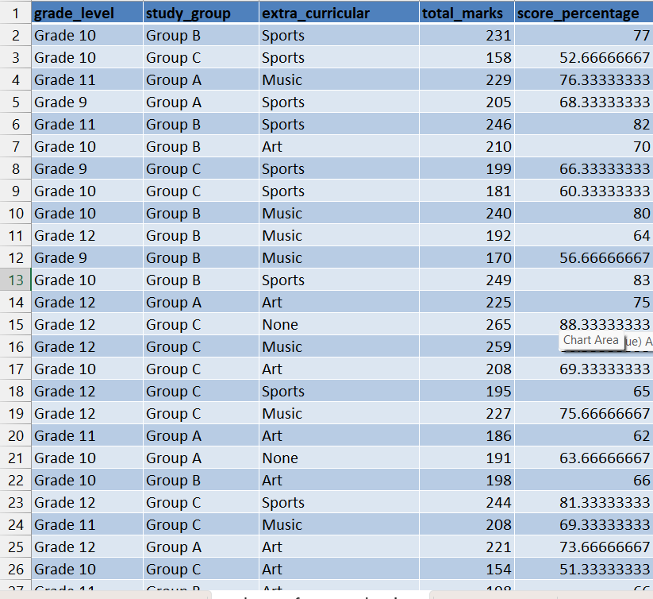

- DashBoard

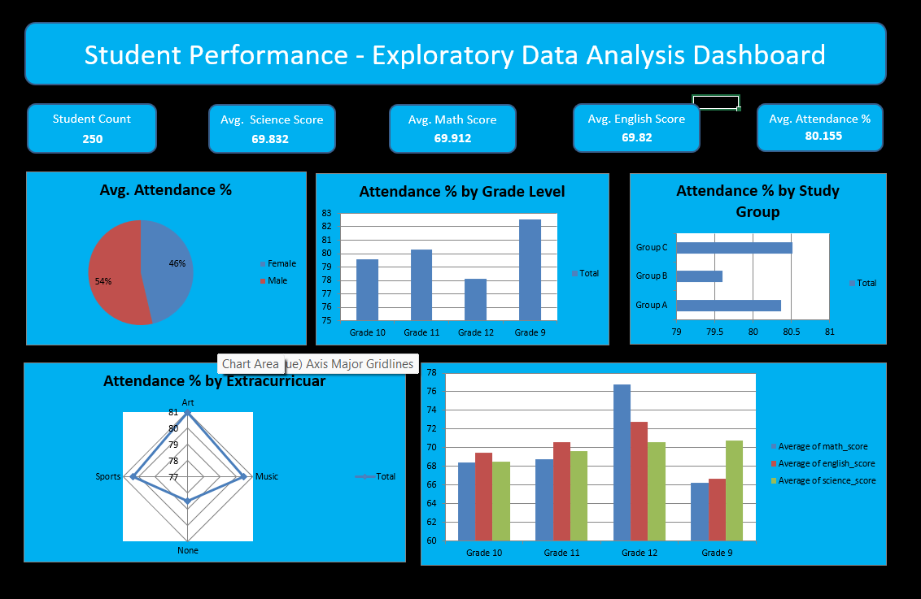

- Pivot table

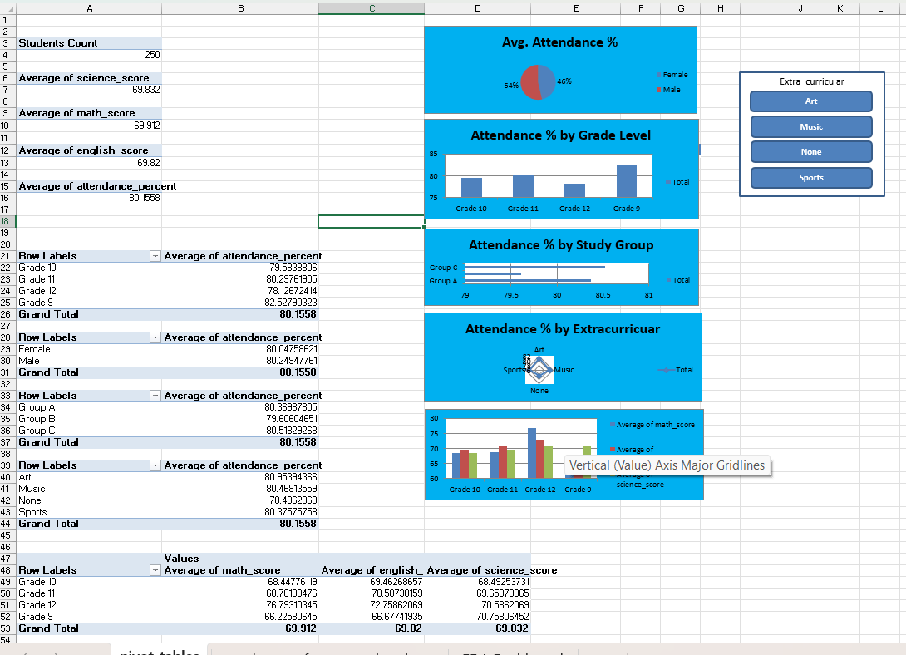

- Conclusion

This project successfully demonstrates the use of Microsoft Excel as a powerful data analysis tool. By converting raw student data into an interactive dashboard, the project enables quick understanding of academic performance.
It helps in:
- Identifying weak students
- Monitoring performance trends
- Improving teaching strategies
Overall, this project enhances efficiency, accuracy, and decision-making in education systems.

- LEARNING OUTCOMES:

- Gained hands-on experience with Excel formulas and functions
- Learned how to create pivot tables and charts
- Developed skills in data visualization
- Understood dashboard design principles
- Improved analytical and problem-solving skills
- Learned how to extract meaningful insights from raw data

